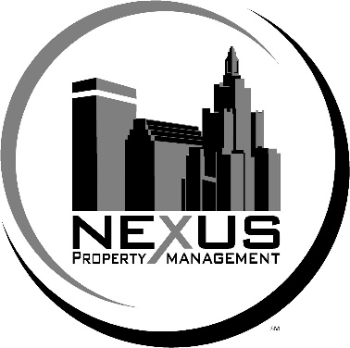
Fast Fact Sheet

Established: June 2012
Began Franchising: April 2017
Total Invest $50K-$106K

Min Net Worth $100K

Franchise Fee $25K first franchise
$15K each additional franchise

Royalties 6% of Property Management Revenues
2% of Maintenance Revenues

System Adv 1% of both Property Management and Maintenance gross revenues. Create/implement to benefit ENTIRE System

Local Adv No local advertising requirement.

Training: 5 days at Corporate and up to 2 days onsite at your location when opening.

Territory: Protected Territory of up to 5 miles driven in any direction from your location. We do NOT charge any territory fee!

What’s Included: Philosophies, Knowledge, Strategies, Training, Website, Software, Training, Startup Kit (Arsenal of Materials/Privately Owned Products) Radio Show, Protected Territory, Discovery Day

Area Developer Agreements not available at this time.

Term is 5 years. There is no renewal fee.

States not available: CA, HI, IL, IN, MD, MN, NY, NC, ND, SD, TX (waiting), VA, WA, WI

We will register in these States for serious applicants.

Description of Franchise Business:

The franchise offered is for the operation of a real estate property management business. This is a service oriented business that offers a one-stop solution for residential and commercial property owners seeking assistance in finding, qualifying and managing tenants, documentation, lease enforcement in addition to identifying, coordinating and/or performing all property maintenance repairs, under the name “Nexus Property Management.”

The Nexus Property Management business model has been developed to offer comprehensive property management and maintenance services for residential and commercial property owners. The Nexus Property Management philosophy is centered on the belief that attention to details in all aspects of managing and maintaining properties leads to high tenant retention and a hassle-free experience for property owners. This is a service oriented business that is typically operated year around out of a small office space or free-standing structure (all of which must be approved by us). Franchises will be offered to qualified individuals who can choose to either have the general maintenance work performed by independent contractors (recommended) or can choose to perform all general maintenance work themselves. Each Nexus Property Management franchise will provide comprehensive property management services while utilizing our proprietary and privately labeled software to offer: tenant acquisition services (such as: advertising and marketing vacancies, screening tenants, qualifying tenants, processing applications, etc.), leasing arrangement services (advice and assistance, contract setup, execution, enforcement, renewals, etc.), rent collection services, our proprietary tenant guarantee program, rent ready services, digital documenting and cataloging services, financial reporting services, ongoing communications (with tenant and property owner) using our proprietary web portal, ongoing maintenance services to identify, coordinate and ensure proper upkeep and all repairs for the property and equipment within the property are performed in addition to providing our privately labeled personal care products (such as: shampoos, conditioners, lotions, etc.) to tenants along with other residential property related services and products approved by us. We may authorize you to offer additional services and products in the future such as: drain cleaning services, debris removal services, gutter cleaning services, landscaping services, basic cleaning services, equipment rental services, disaster response services, investment property consulting services and other property-related services and products approved by us.

Few Important Facts:

- Low start-up costs, low overhead. Can operate out of small 500 sq foot office;
- Value to single homeowners as well as seasoned investors;
- Multiple profit centers. This is really two businesses in one;
- Property Management portion of business utilizes our proprietary and privately labeled software to help streamline operations;
- Learn about our tenant acquisition programs and how to process and manage tenants;
- Learn about and how to offer our proprietary tenant guarantee program;
- Access to our preferred vendors, proprietary educational platform and software;
- There is no seasonality to this business; Recession resistant;
- We will teach you how to market, advertise and attract clients and secure accounts;
- NO territory fee and tons of territory available;
- Emerging brand (grandfather in on ground floor, pioneer in your area before sells out);
Ideal Candidates:
May need to have (or partner with someone who has) a residential real estate broker license
No Property Management or Maintenance Experience Required
Open to new technologies
Calm Demeanor
Must be passionate about quality
Must be detail-oriented
Interpersonal / Strong communication skills
Must actively participate in the business
Positive attitude, strong work ethic and energetic

Contact Information for Nexus Franchise, LLC:
Greg Rice
49 North Union Street
Pawtucket, RI 02860

(888) 639-8755 (Toll Free)

Franchise@NexusPropertyManagement.com

